The Summer Park is an outreach of First Covenant church  The Park is part of a vision of God’s work in reaching people in the church neighborhood and larger community with the love of Christ.  We offer a safe place for students to come during the summer school break. This is a park experience that offers a loving and warm environment with a staff that is trained to emulate a positive role model for the students. | 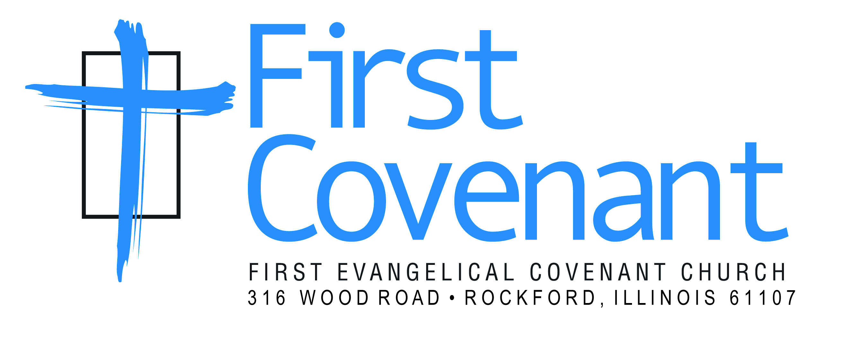 |  | 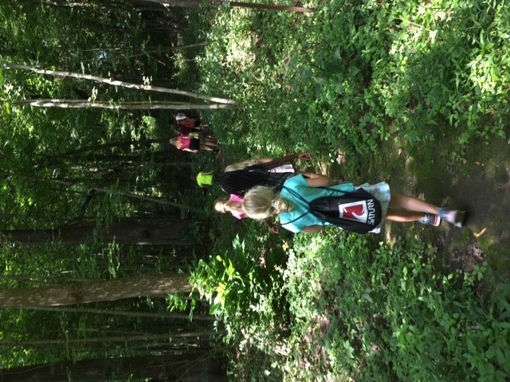  Summer Park 2019  - The summer park program from First Covenant Church  - June 10th – August 7th  - 9am – 3pm  - www.firstcovrockford.org

Summer Park  Summer park offers week day activities from 9am – 3pm.  Weekly themes and field trips  Wet Wednesdays and Fun Fridays  All Summer long  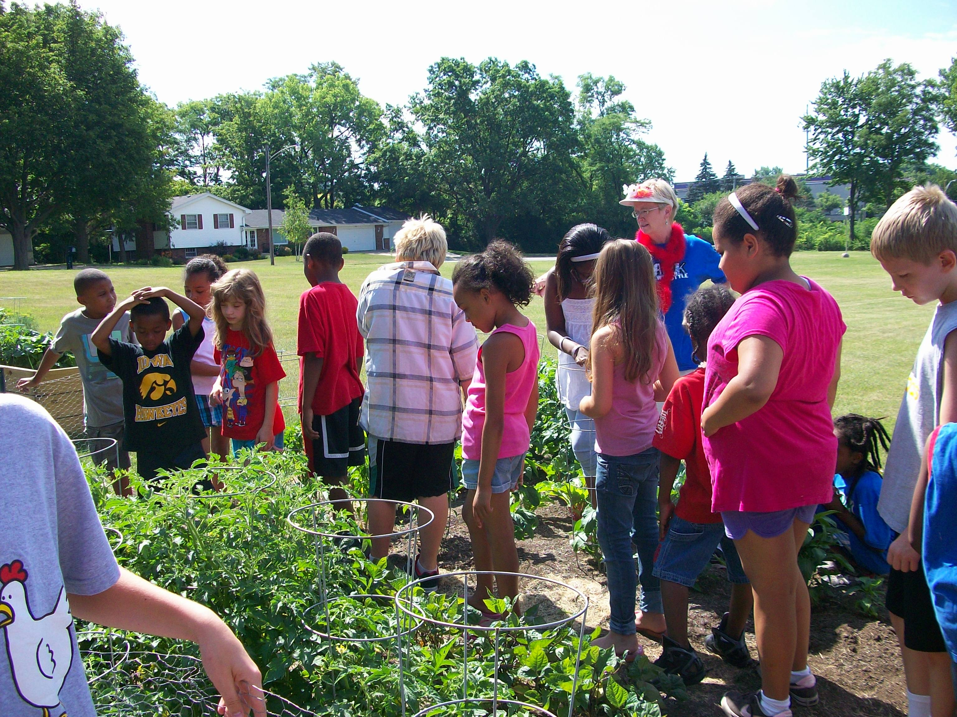  Extended care is available by reservation 7:30am to 9am  and 3pm – 5:30pm  $5.00 per session $8 max per family | 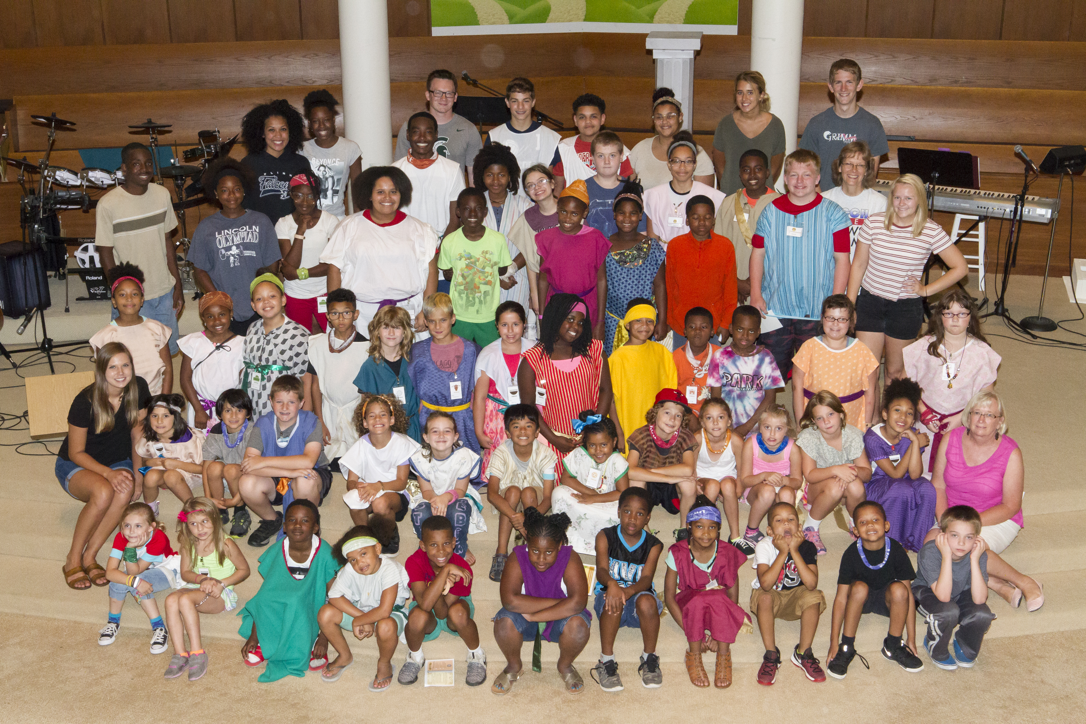  Who can attend: Anyone that is entering 1st grade thru having finished 5th grade  Daily Activities Include  Outside games  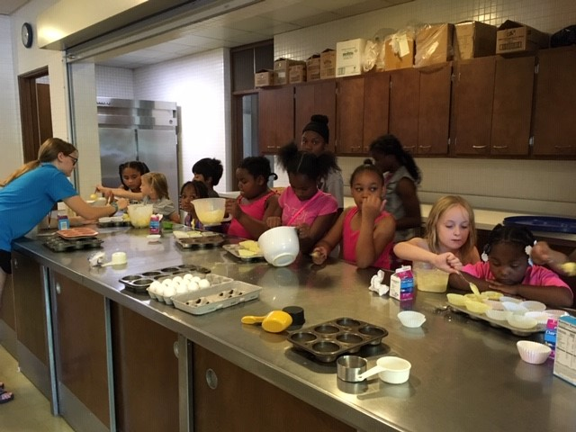  Crafts  Music  Small group time  Bible learning  Free lunch provided  Cooking and art classes  Sports focus groups | 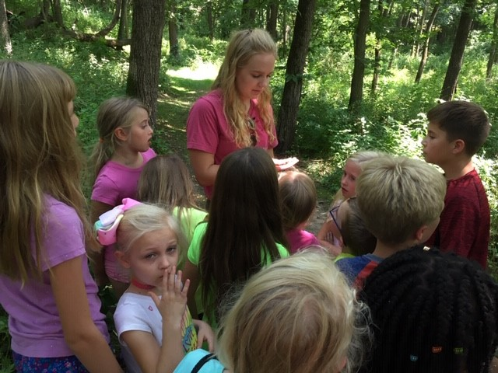  Staff  We have a trained staff to teach and have fun with your student  Signing Up  A registration form is needed before your student can attend. $60 for the summer per student or pay $10 each week. $150 family max. Scholarships available.  This year space is limited, so sign up early to hold your spot. Registration forms are available in the church office or online. Sorry, no online registration is available.  Contact Us  316 Wood Rd.  www.firstcovrockford.org  815-398-4247

